**ALOHA:**

Aloha is a tool used to generate threat zone at the time of petrochemical accidents.

This tool allow user to select accident location in four ways

* Lat, Long
* By selecting industry
* By selecting District, Taluk and Village
* By picking location point.

After selecting location it displays location and weather information. User use this information for ALOHA tool. This tool generates threat zone based on accident information given by user. User exports this threat zone as KML and select text information as copies to clip board. Then user click on display threat zone button it displays threat zone in Arcmap, later user analyse the threat zone.

**Software Requirement:**

* Aloha

1. **Open Arcgis, drag and drop Arcgis ArcMap document.**

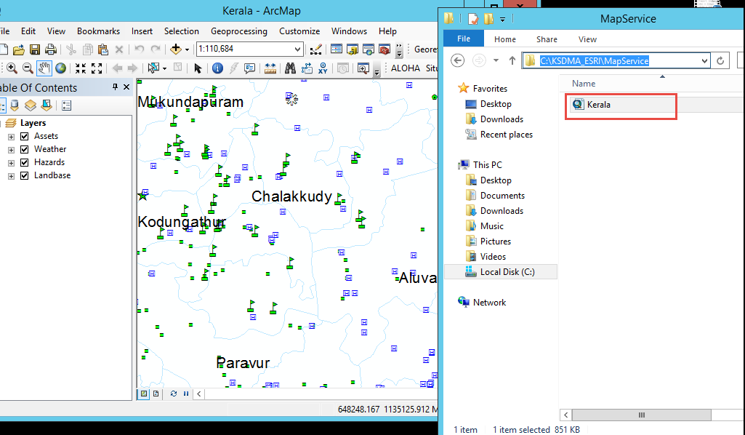

1. **Add ALOHA Tool to ArcMap.**

Customize > Customize mode > Commands > [Select_Name] e.g.: KSDMA > ALOHA.

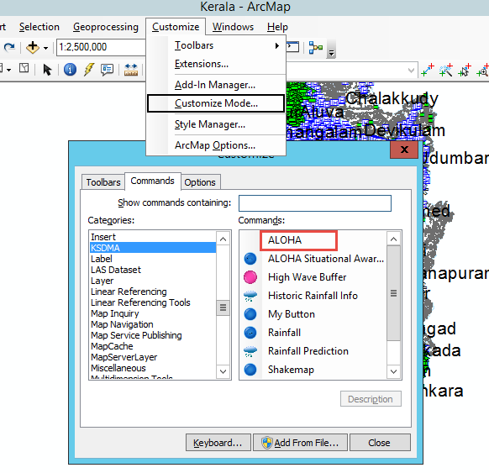

Now drag and drop ALOHA tool to your toolbar.

1. **Click ALOHA button and open ALOHA tool and select accident location by any of given four categories.**

**Lat/Long** **District/Taluk/Village** **Industry** **Location**

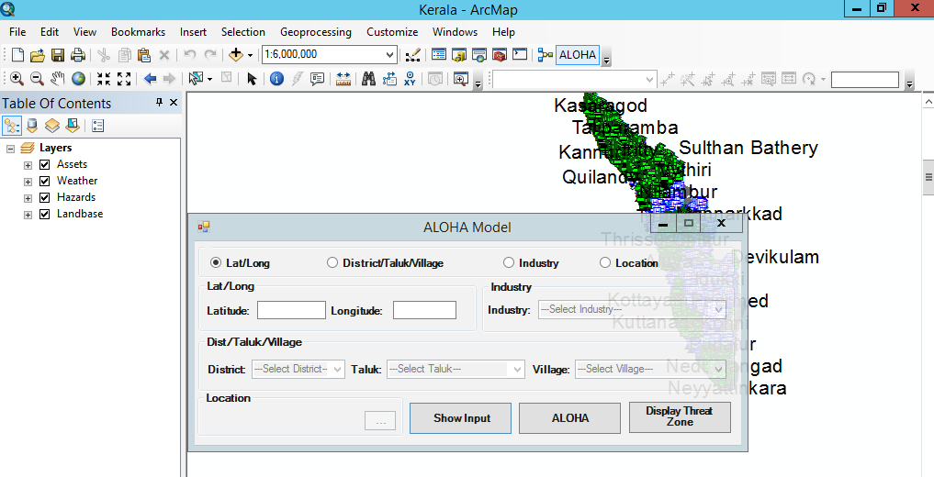

It will disable the other options once you select any one of them. After selecting category provide the appropriate information.

1. **Click Show Input button to generate information as a text file.**

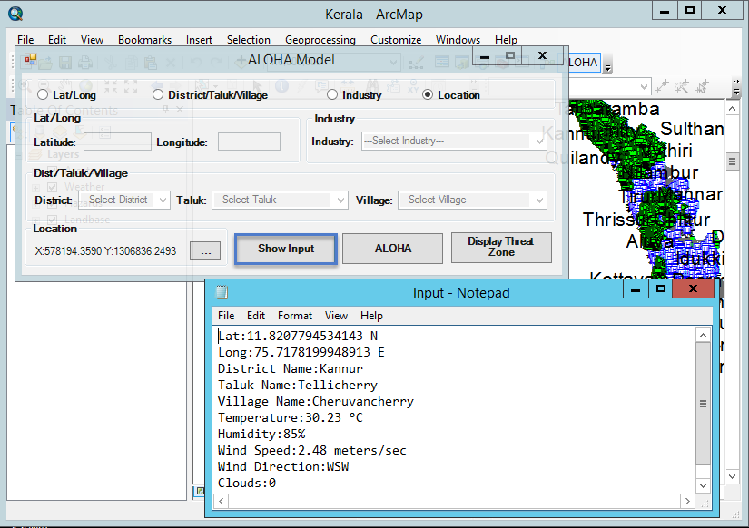

This text document contains all the required information like temperature, wind speed, cloud etc.

1. **Click ALOHA button to open ALOHA.**
2. **Select set up from tool bar in aloha to set chemical.**

Set up > select Chemical

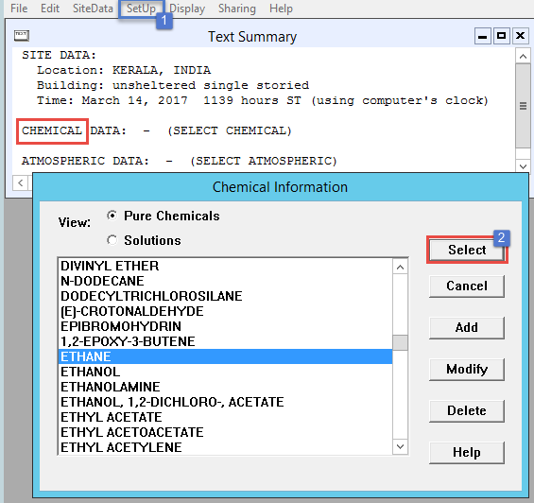

1. **Set up atmosphere user input**

Set up > Atmospheric > User input

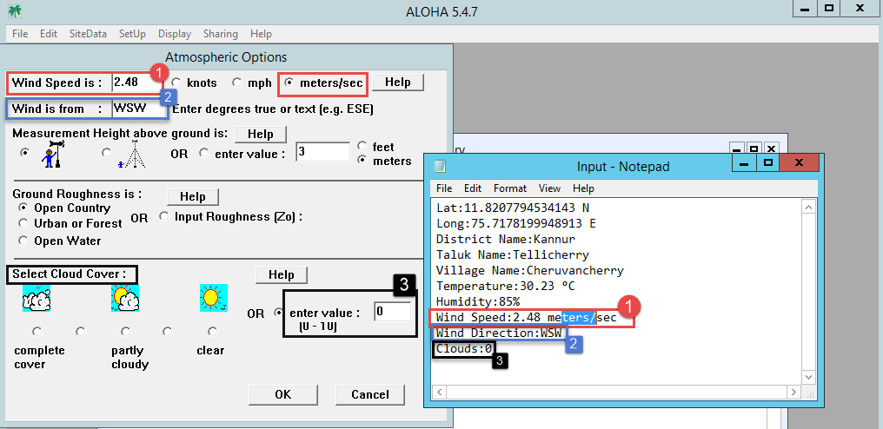

Fill the required information from text file.

1. **Fill air temperature, humidity as per text file.**

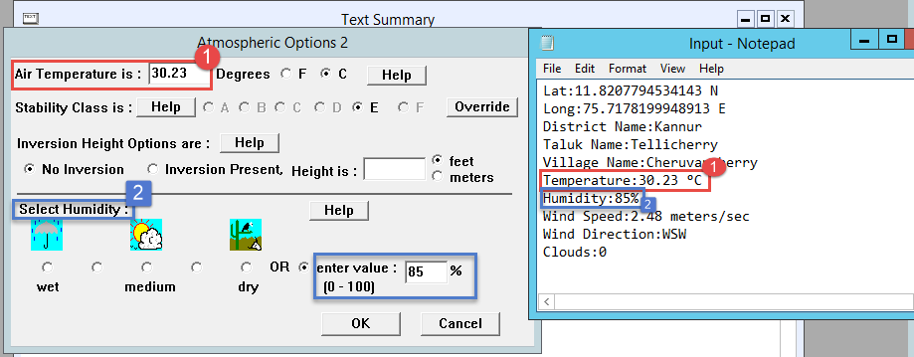

1. **Select the source of accident and enter appropriate information.**

Set up > Source > [Direct / Puddle / Tank / Gas Pipeline]

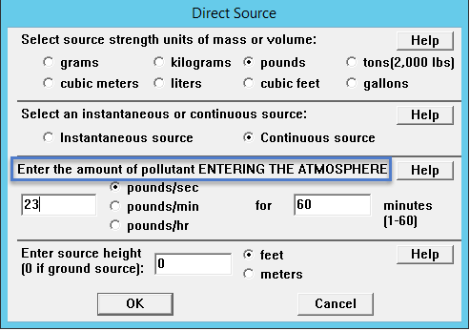

1. **Display Threat zone**

Display > Threat zone > [Choose hazard to analyze] and provide appropriate information.

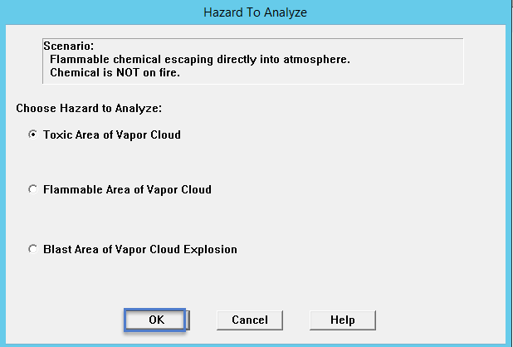

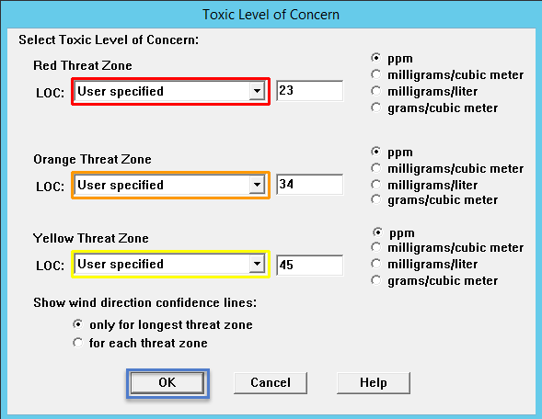

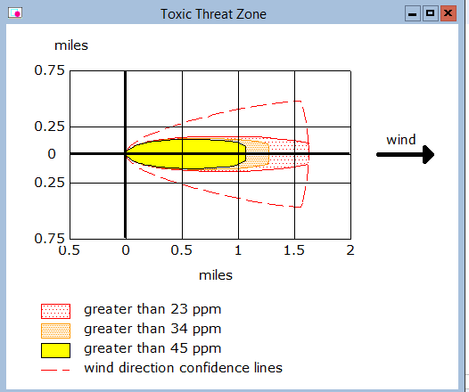

1. **Export threat zone**

After displaying threat zone export the threat zone in KML File format and provide Lat and Long from text file.

File > Export threat zone.

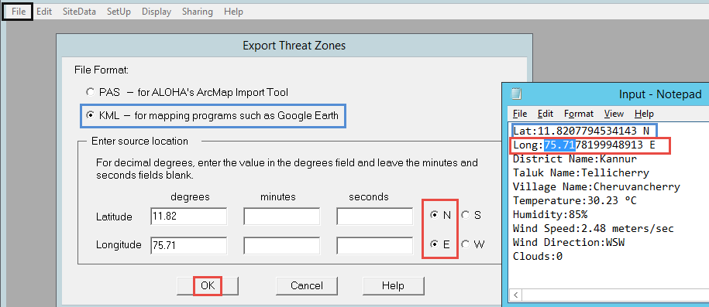

1. **Save Threat zone export file with “ThreatZone” file name.**

To do so create a new directory “ALOHA” in your workspace

E.g.: C:\KSDMA_ESRI\Workspace\ALOHA.

Now select this location and save ThreatZone file there.

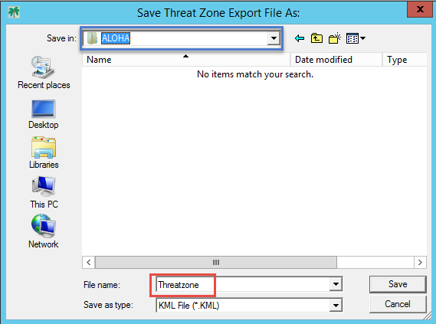

1. **Now copy the entire text summary from ALOHA.**

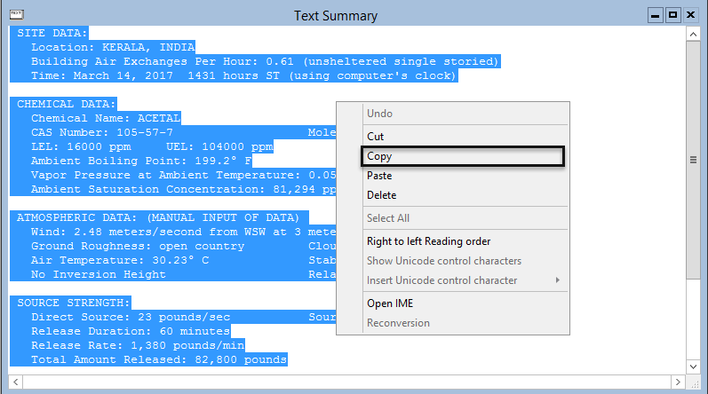

1. **Go back to ALOHA tool and click Display Threat Zone button.**

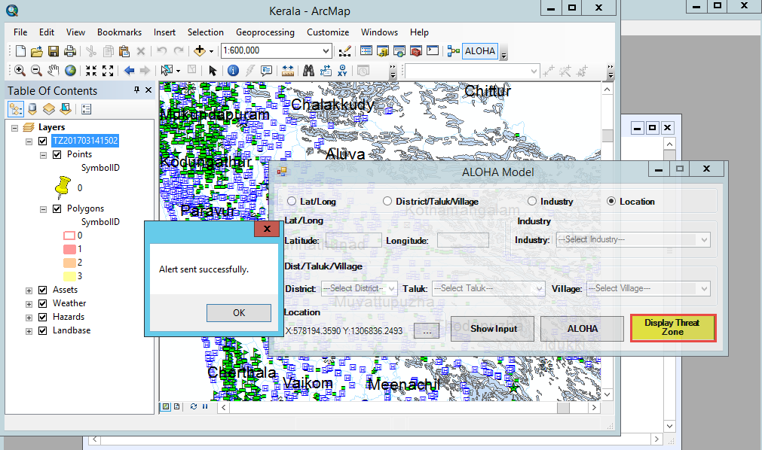

1. **Zoom to layer to display the threat zone**

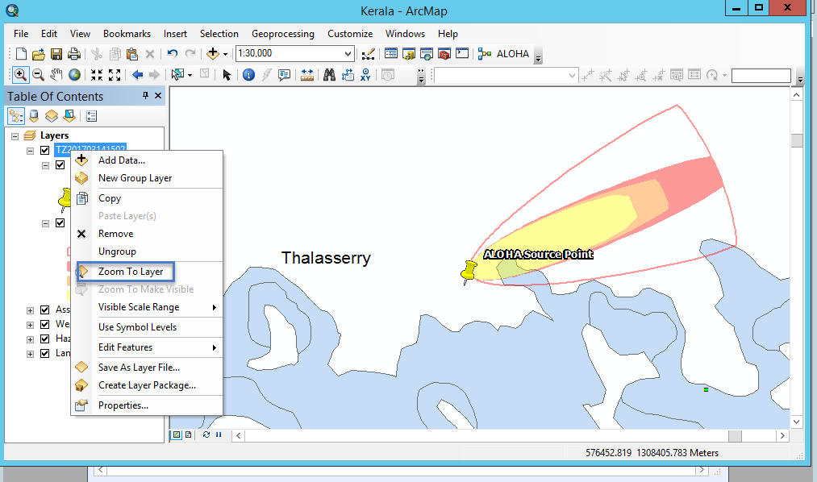

Here in this threat zone ‘ALOHA Source Point’ indicates the source accident location. Each colour indicates different range of effect. One last outer border indicates the maximum area which can get affected by the accident.

By analyzing the Threat Zone one can identify the assets and can take appropriate action.

**ALOHA Code Flow:**

* **Set ALOHA Tool**

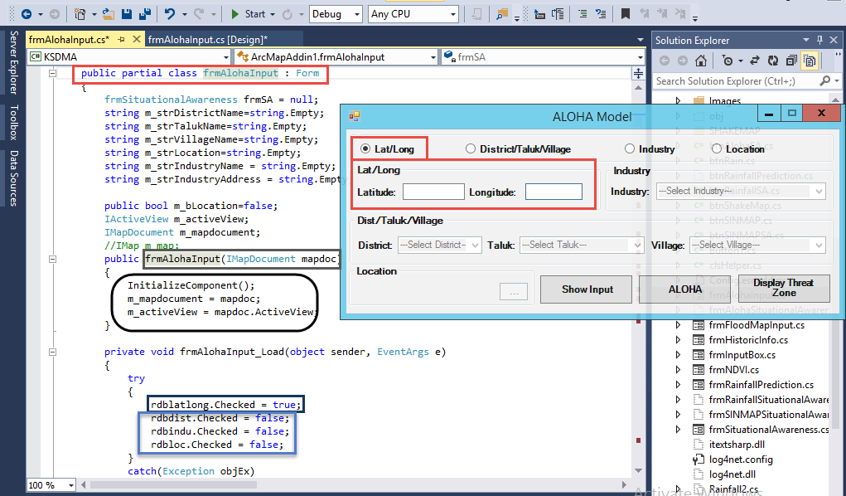

To access ALOHA Tool directly from Arcgis software we need to set ALOHA tool. For that here we are declaring and initializing all the required variables.

Here we declared rdblatlong.Checked= true; [radio button Lat/Long] and all remaining false to disable all other categories.

We used following methods to check and change radio button and to further process.

private void rdblatlong_CheckedChanged (object sender, EventArgs e){}

private void rdbdist_CheckedChanged (object sender, EventArgs e){}

private void rdbindu_CheckedChanged (object sender, EventArgs e){}

private void rdbloc_CheckedChanged (object sender, EventArgs e){}

* **To change combo box selections:**

private void cmbdist_SelectionChangeCommitted(object sender, EventArgs e) {}

* **To handle key press event:**

private void cmbtlk_KeyPress(object sender, KeyPressEventArgs e)

{

e.Handled = true;

}

* **Show Input button:**

To get flow from Show Input button:

private void btnShowInput_Click(object sender, EventArgs e) { }

This method will check for appropriate inputs by checking conditions like

if (rdblatlong.Checked){} //radio button Lat/Long

else if (rdbdist.Checked) {} //radio button District

else if (rdbindu.Checked) {} //radio button Industry

else if (rdbloc.Checked) {} //radio button Location

If the above condition satisfies then it will get the location from database and displays information as follows otherwise it’ll display error message.

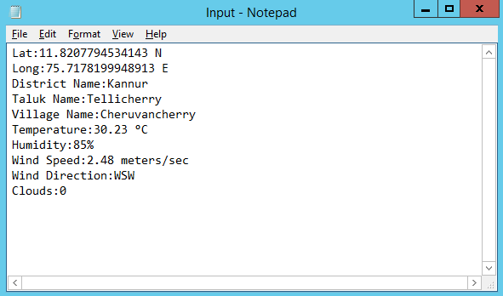

* **ALOHA Button:**

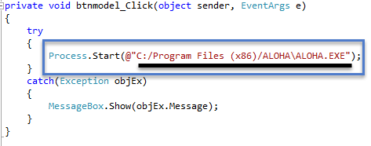  
Process.Start (arg ) will start the software as per given argument.

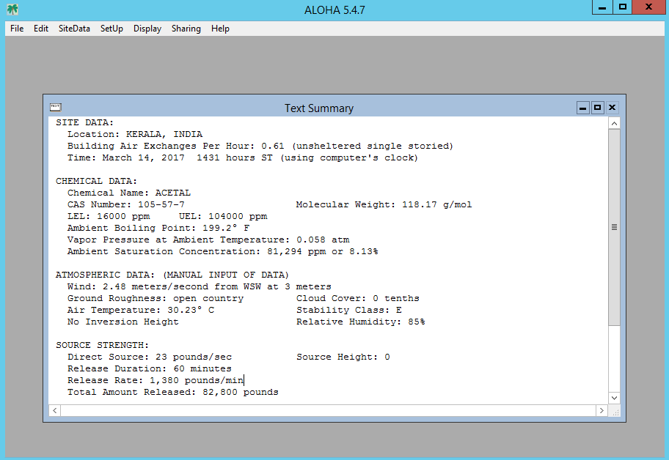

Here fill all required information as per text file generated by Show Input button.

* **Display Threat Zone Button:**

To create Display Threat Zone button we’ll use following method.

private void btnThreatZone_Click(object sender, EventArgs e) {}

* **To Read information in a text file:**

ALOHA.clsTextSummary objTextSummary = new ALOHA.clsTextSummary();

objTextSummary.Read();

The above method will read data in a text file and the text file will be stored in one of these directories with the accident source type name.

E.g.: DS_Sno //[Direct]

GP_Sno //[Gas Pipeline]

TNK_Sno //[Tank]

PDL_Sno //[Burning Puddle/Pool Fire]

Now by using string strTZName = String.Format("TZ{0:yyyyMMddHmm}", dt); the file will be stored with [TZ0 ’Date’] folder name.

Now we’ll use

ESRI.ArcGIS.ConversionTools.KMLToLayer KML2Layer = new ESRI.ArcGIS.ConversionTools.KMLToLayer(); to convert KML file into layer.

Now we’ll use execute method to display assets in threat zone and to store data in database and in respective accident source database.

ALOHA.clsExportMap.Execute(m_mapdocument, strFileName + ".png", strEventID);

On successful process it’ll generate a message box to display [alert sent successfully].

MessageBox.Show("Alert sent successfully.");